I started this relatively early and have a cold/viral infection. I actually came home from work early. I kept getting errors and could not copy and paste the query so that took the most amount of time and is the reason my assignment is a little after midnight.

Part 1

1

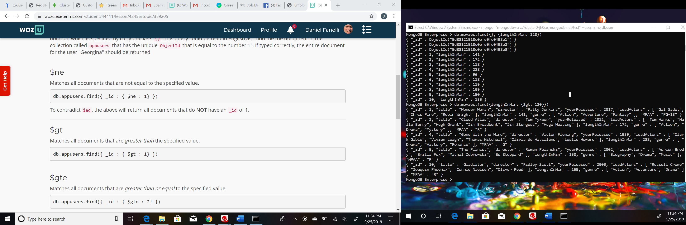

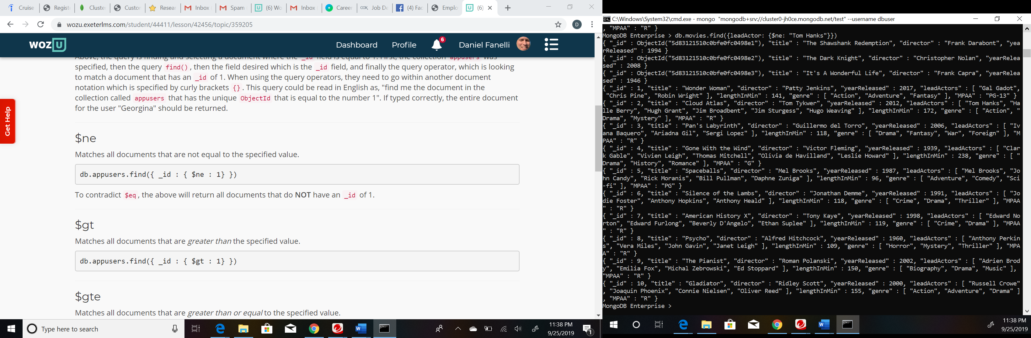

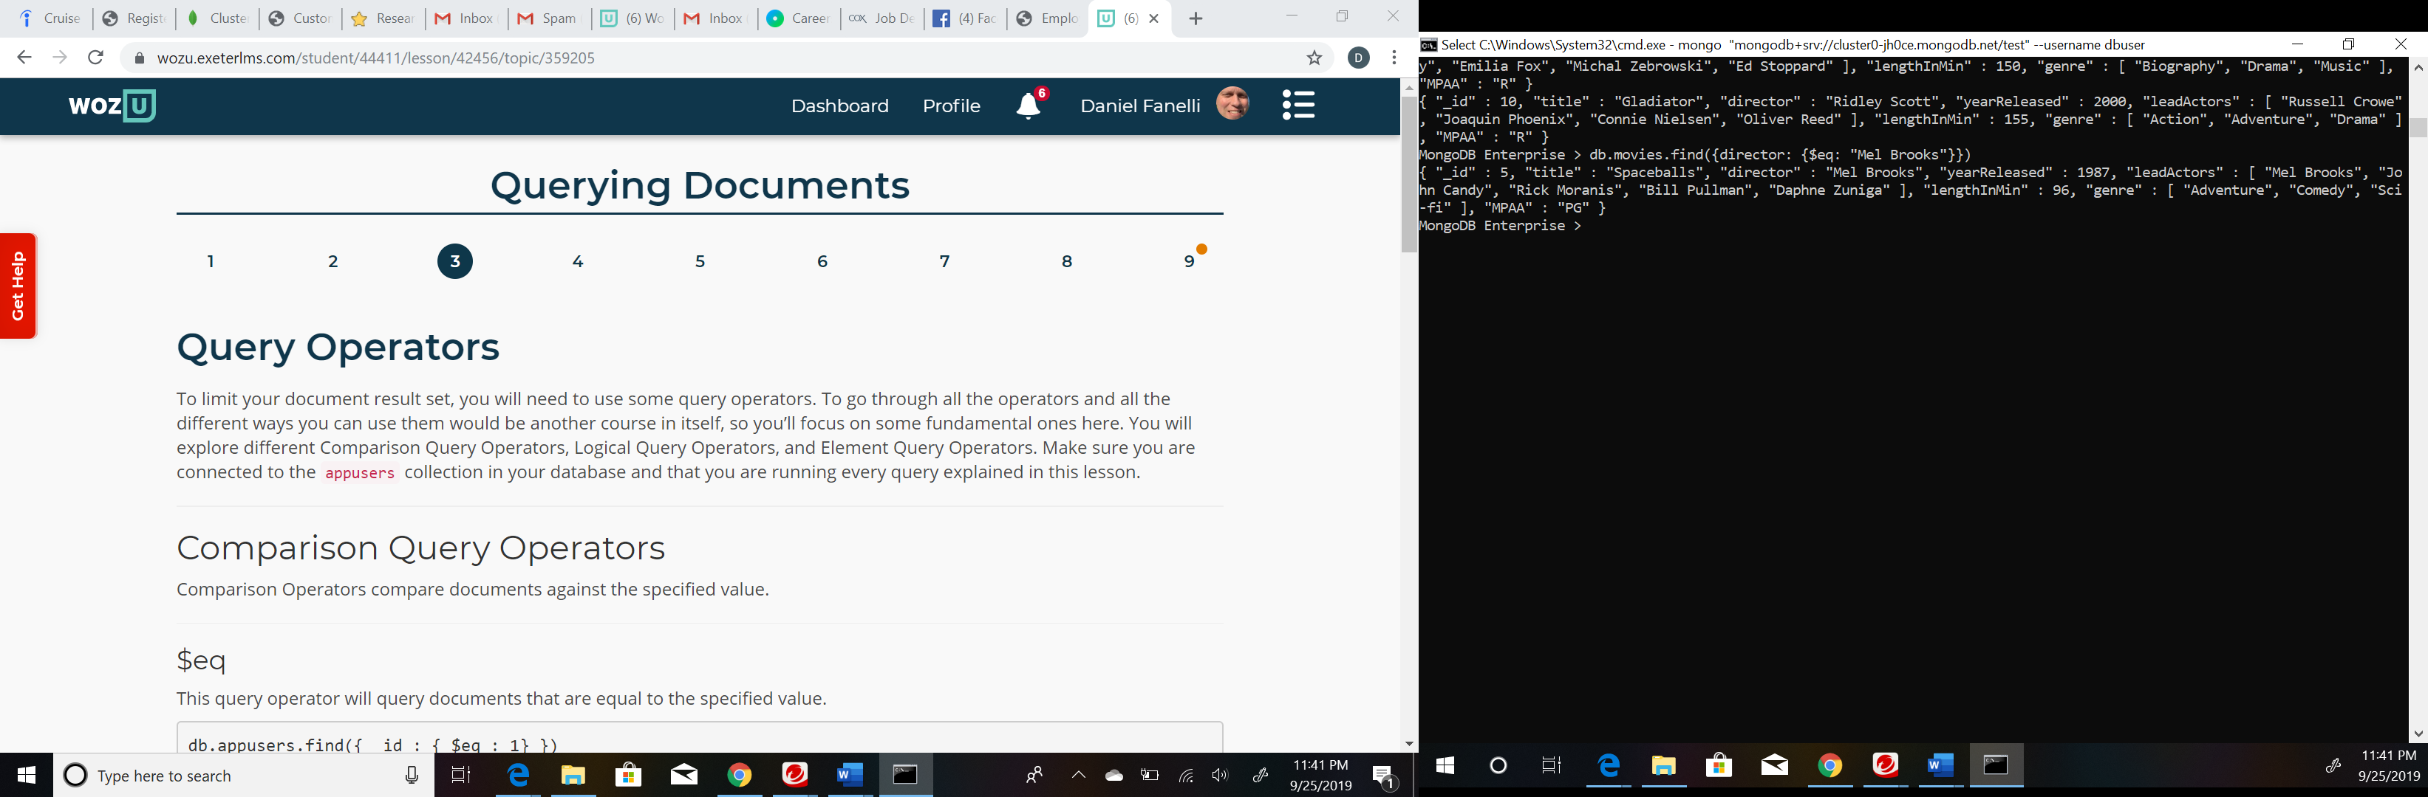

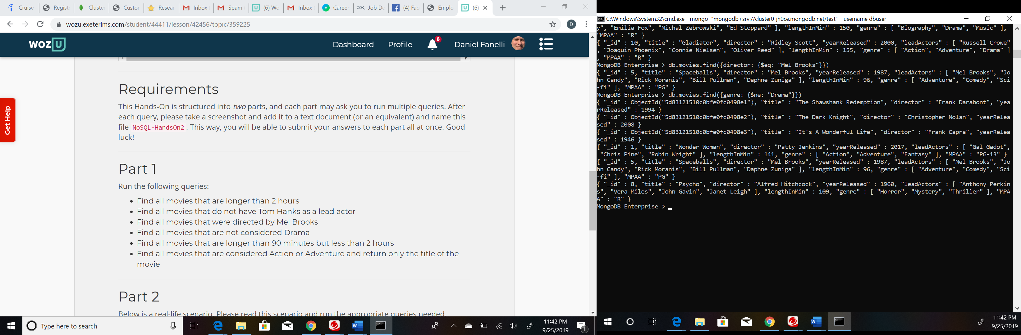

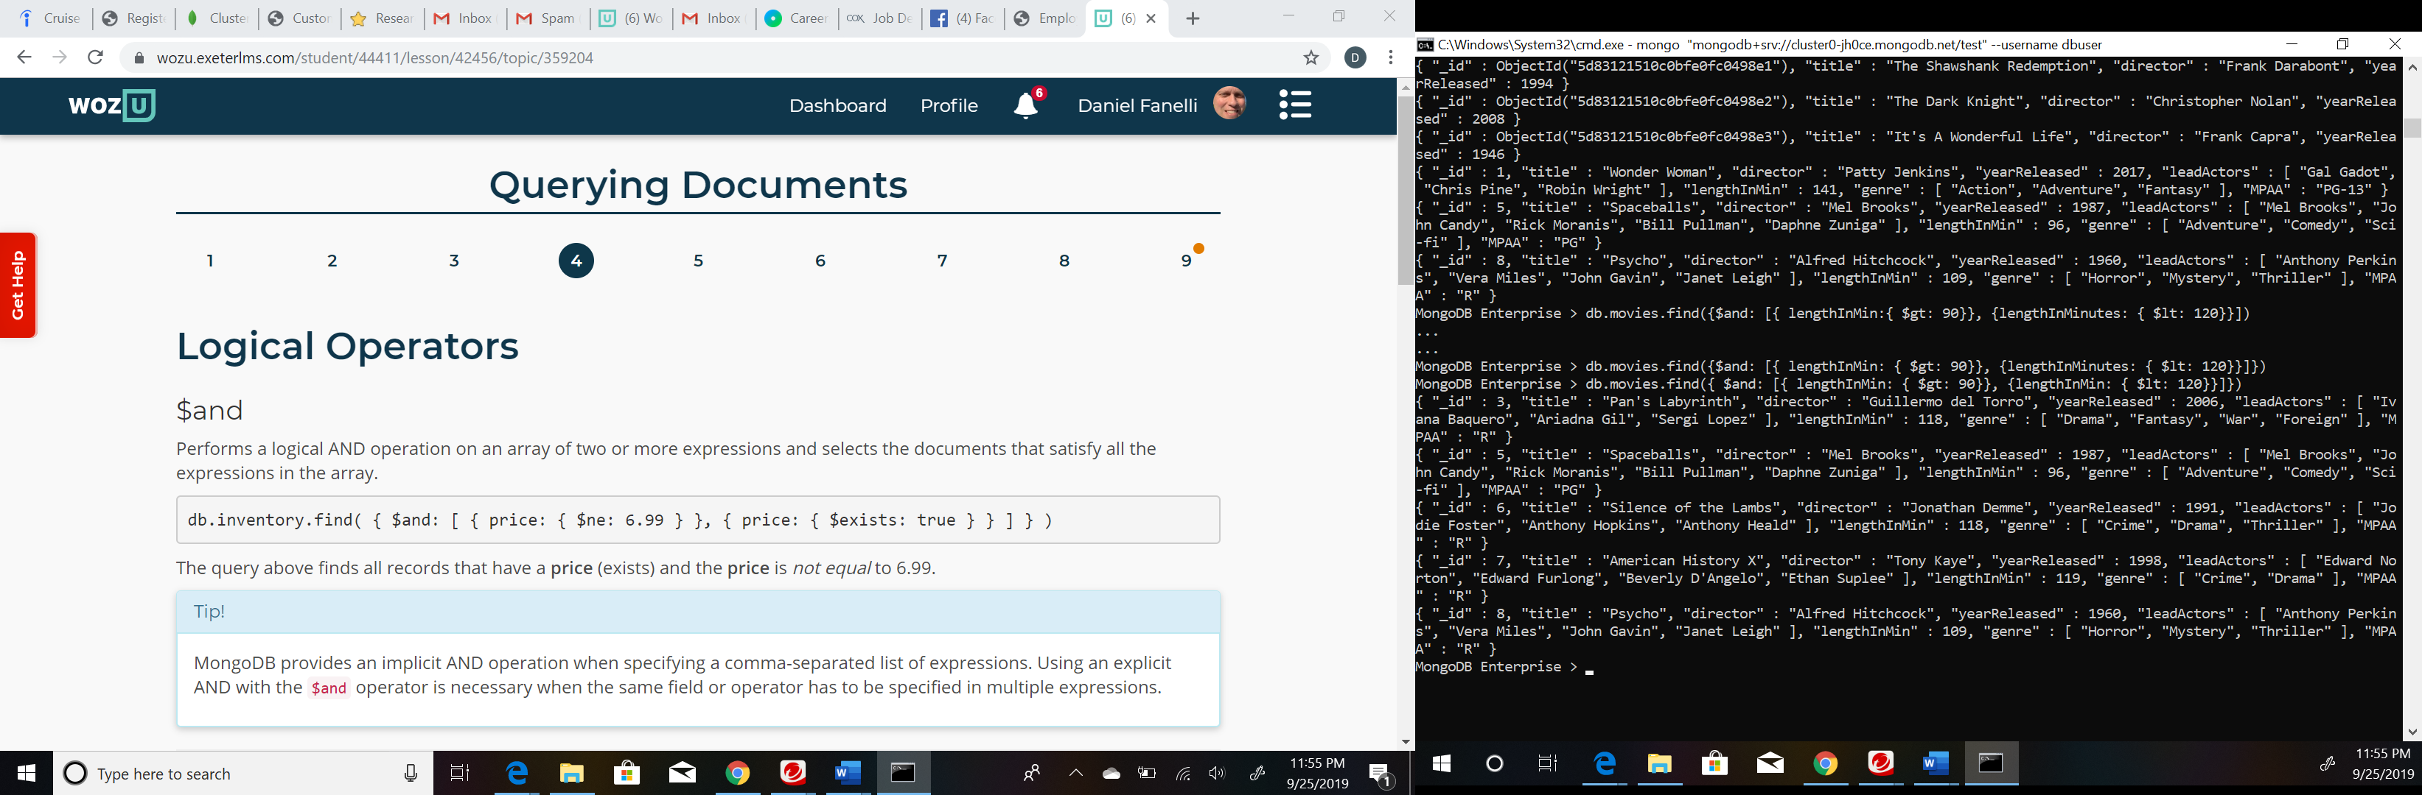

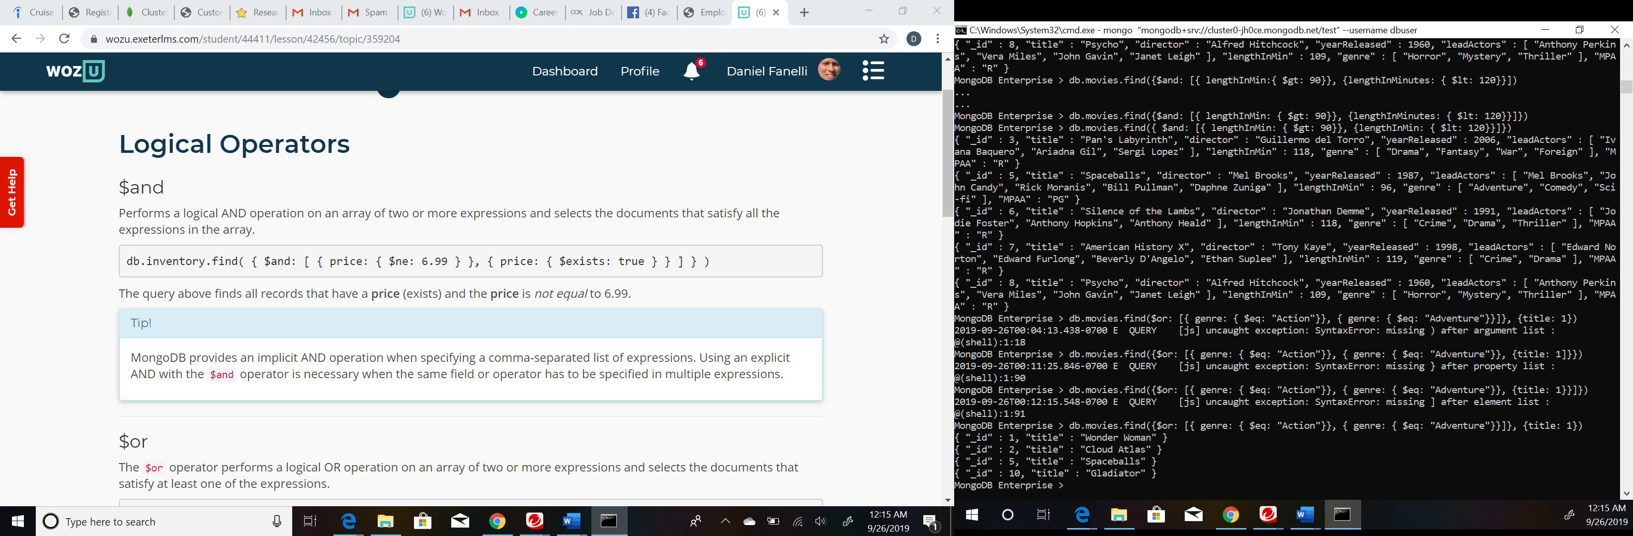

Part 2

1) 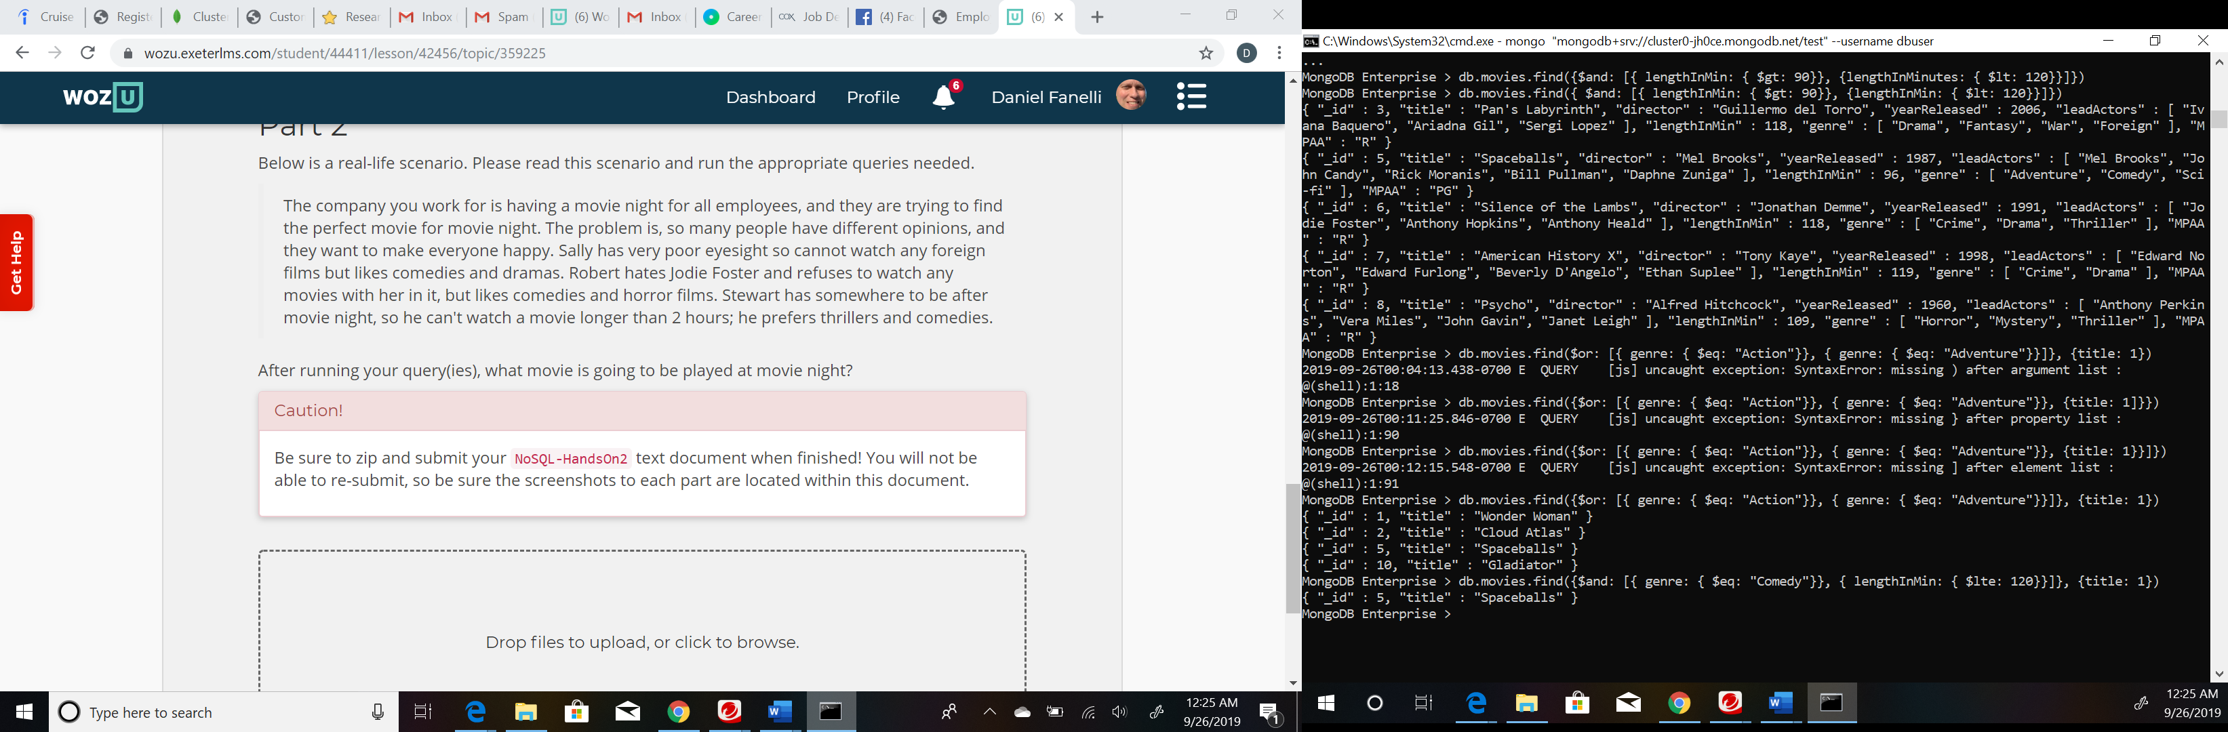

Spaceballs would be the movie played. The query didn’t have Jody Foster, Drama, or Thriller, so one everyone would enjoy.